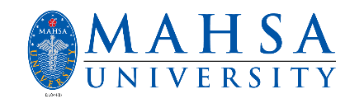

The P@TH
Centre for Pre-University Studies, Issue 1 / 2019 / April | Special in this issue:  - Designers’ baby! How much do you know about it?  - Pre-U students in English competition.  - Test your Cell Biology with our crossword puzzle!  Highlights:  Message from Assist. Director -Page 2-  Message from Editor -Page 2-  New editorial team members, welcome! -Page 2-  Designers’ baby: Engineered to be HIV-resistant, but may be more than that! -Page 3-  English Appreciation Month: Toastmaster and Poetry Recital Competition -Page 4-  Crossword puzzle -Page 5-

Quote of the day:
“Knowledge is power. Information is liberating. Education is the premise of progress, in every society, in every family.”

- Kofi Annan -

Message from Assist. Director |  | New editorial team members, welcome!  Like all things, nothing will come of nothing. The Path, the newsletter is made possible by the efforts of our editors/writers.  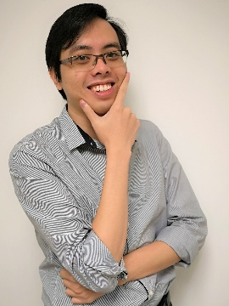  Dr Chew Weiyun  -Grow through what you go through-  Ms. Norlaila Najwa bt. Rahman  -She believed, she could, so she did.-
Dear colleagues, students and friends,  The year 2018 has been a fruitful year for MAHSA community. With the constant support of dedicated staff working toward a common goal, we have finally seen a transition in the University. At the same time, the Centre for Pre-University Studies is proud to present the first issue of “The Path”.  The Centre for Pre-Universities Studies provides a gateway to the entry into our Bachelor degree programmes. Apart from preparing the students for the transition from school-based learning to university-based learning, providing the student with university life experiences is equally important. Throughout the studies, our students will be exposed to various experiences of different professions, allowing them to gain an idea of the work of different professions before they eventually enter into the Bachelor degree programmes. To achieve this, our students will engage in the activities organised by the Faculties. Hence, these activities will be highlighted in “The Path” and published in a timely manner.  The newsletter is an essence of our dedicated staff in nurturing the Centre of Pre-University Studies students. We hope our efforts would stimulate better learning experiences, in shaping holistic graduates.  Assistant Director,  Centre for Pre-University Studies,  Dr How Chee Wun | 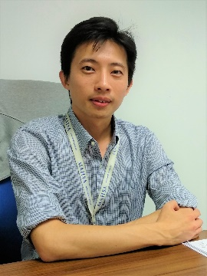

Message from Editor
“Education is the passport the future, for tomorrow belongs to those who prepare for it today”
– Malcom X. –

The future of humanity belongs to the younger generation! As it is so, we—the Centre for Pre-University—recognise the importance of a conducive environment for education and growth of each and every student. We firmly believe that education is a powerful tool that can shape the future of humanity, and as such, we consider quality education as our top priority.

At the Centre for Pre-University, every staff member is dedicated to provide their utmost care and consideration for every student enrolled in our programme. In response, the students under the Pre-University programme display unlimited passion and dedication to learning. We deeply cherish this dynamic relationship between the staff and students. For that reason, I wish to shoulder the task of conveying the efforts of the staff and students alike to the community. Consider this as my heartfelt gratitude for being given the opportunity to be a part of this wonderful family—the Centre for Pre-University.

That being said, this quarterly newsletter is the first issue of 2019. What do we want to express with our quarterly newsletter?

The quarterly newsletter is our small attempt to convey the activities happening around the Centre for Pre-University, for the students and staff members. At the same time, we would like to provide our readers with news on the latest scientific advancements. The puzzle at the end? It is our little treat for your brain ;-)

We hope you will enjoy our humble newsletter.

Editor, The Path,
Dr Chew Weiyun

Designers’ baby:

Engineered to be HIV-resistant, but may be more than that!

“Today, genetic engineering can be as easy as adding a few drops of acid into a solution”  Back in the 1980s, the use of computers was merely for working and there were no online shopping, dating and stock market. Never had they imagine that smartphones and supercomputers will become a reality and just by a few clicks you can now purchase an item. Items that seem to appear only in science fiction is becoming a reality today and this is what is happening to our genetic engineering.  Today, genetic engineering can be as easy as adding a few drops of acid into a solution. Since the first discovery of CRISPR by a group of scientist lead by Yoshizumi Ishino in 1987. They have no idea of their discovery could be anywhere revolutionary. 25 years later, the biochemist, Jennifer Doudna, generates great hype as it shows gene can be edited easily with CRISPR technology she invented. Since then, scientists all around the world are frantically researching the gene editing technology. 4 years later, a piece of news shocked the whole world, the Chinese scientists announced that they have produced designer babies (twins). This turn of event causes an uproar among the science communities. More than ever, the science communities are now calling for an ethical code of conduct for genetic researches.  The designer babies they have produced is resistant to HIV (human immunodeficiency virus) through genetic engineering. A technique called CRISPR (clustered regularly interspaced short palindromic repeats) was used to genetically edit the genes of the embryo into a desirable baby. The technique utilizes enzymes to recognize and cut specific strands of DNA that are complementary to the sequence, just like a pair of molecular scissors.  When a protein called CCR5 is present on the surface of the white blood cells (WBC), it allows HIV to attach itself and enters the cell, replicating itself. The gene that codes for this protein is common among humans; however, most of us have a mutated version of it. The mutated CCR5 proteins are smaller in size and are located inside the cell; making it impossible for HIV to attach itself onto the WBC. The Chinese scientists were able to alter the babies’ genome to produce WBC without the protein, thus making the babies HIV resistant. This confirms a plausible cause of eliminating genetic diseases such as cancer, Herpes infections, and somewhat 3000 genetically related diseases (Trisomy 18, Klinefelter, Down syndrome, etc), benefiting humanity as a whole.  However, genetics-altering is rarely that simple!  Recently, it was discovered that, besides catering for the attachment of HIV, CCR5 also governs a person’s learning abilities and memory formation. Under low levels, a person’s ability to learning and memory formation was greatly enhanced. Certainly, it also meant that the stroke patient will recover faster.  However, there is still a lot of uncertainty comes with the possibilities. Will altering the level of this protein meant that producing a more intelligence Homo sapiens? What may happen to babies without this protein? Can the genetically modified gene be passed on to offspring? Shall there be any other complications that we do not know? Did we finally found the fountain of youth? What will humankind be in the future; are we creating aliens or superhuman? These are some questions that need to be answered and there is much more than we don’t know yet. | Authors: Dr Cheong Jee Yin, Dr Chew Weiyun

English Appreciation Month: Toastmaster and Poetry Recital Competition |  |  |  |  | Pre-U student reciting a poem on stage  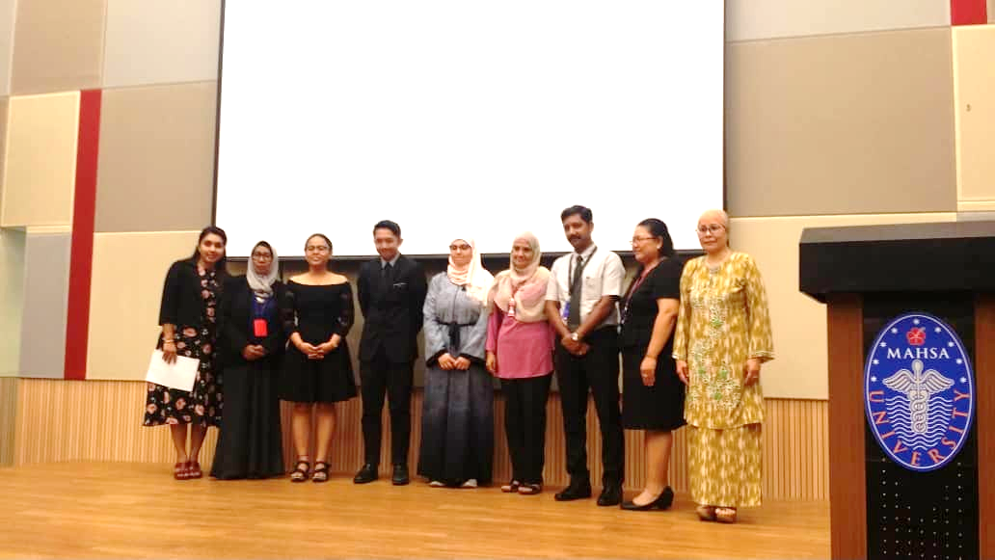  Poem recital organisers  Pre-U student presenting at Toastmaster  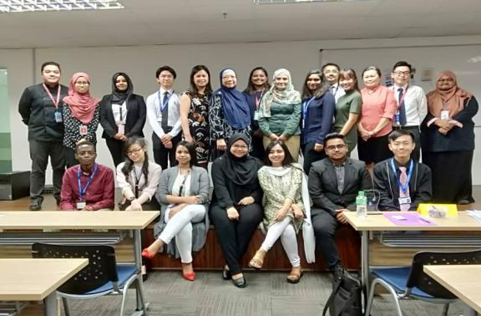  Toastmaster participants and lecturers
Authors: Ms. Norlaila Najwa bt. Rahman

February is an English Appreciation Month conducted by Centre of Education and Learning. Various activities and competitions are held for the students and MAHSA staff to participate, enjoy and simultaneously learn English.

Toastmaster Competition – organized by Faculty of Business, Finance, and Hospitality – is held on 12th February. It is a public speaking activity that gives students opportunity to speak in front of an audience based on given topics. The topic chosen for discussion are: Sex Education Awareness in Higher Learning Education, Should Smoking Be Banned in Eateries and Suicides among Teenagers. Participating in such competition is a great way for students to build confidence and enhance their social skills. On the other hand, public speaking is a great platform to share one’s valuable insight and opinion with the world. Students are given the chance to discuss current issues, while working closely with faculty members at the same time.
While discussing hard facts are undoubtedly a marketable skill for the future, the ability to express those facts in a creative way is just as captivating. Hence for Poetry Recital Competition, social justice is chosen as the theme. Social justice is defined as the equal access to wealth, opportunities, and privileges within a society. Both students and staff participated in the competition. Poem “Still I Rise” by Maya Angelou was recited by both the winner and the first runner up. Maya Angelou was an American poet, singer, memoirist and civil participants are given the freedom to express feelings to their audience, conveying the messages of the poems in a fun and creative way.
All in all, learning a new language is not only fun, it also opens up a whole new world to be explored. English, like any other language, is not merely a tool of communication – it’s also a bridge to new culture, opportunities, and insights you could never really experience without learning the language.

“Language, is not merely a tool of communication – it’s also a bridge to new culture, opportunities, and insights.”

Crossword puzzle

Cell biology  How many organelles you know? |  |  |  | Across  2 Enable for cell movement. Example sperm  4 Site of photosynthesis in plants  6 Energy production by ATP synthesis  7 Responsible for protein synthesis  8 Stores enzymes responsible for intracellular digestion  Down  1 Control centre of the cell. Stores DNA  3 Responsible for the modification, sorting, and transport of macromolecules throughout the cell  5 Central large found only in plants. Responsible for plant turgidity – allows a plant to stand upright
 |  |  |  | Answer

Upcoming activities

MAHSA University is committed to have monthly activities based on theme.

Please join us and have fun!
 | Month | Theme | Organiser
 | Mar | Go Green Month | Faculty of Engineering and Information Technology
 | Apr | Arts and Music Month | Students’ Representative Council
 | May | CSR Month | Faculty of Dentistry
 | Jun | Family Appreciation Month | Centre for Pre-University Studies

Write us your articles / opinions / poems

- Have opinions or perspectives wants to voice out?
- Want to write up on some interesting articles?
- Want to join the fun of creating a puzzle?

NOW YOU CAN!!

Send your materials or manuscripts to us!
Email: wychew@mahsa.edu.my

*Our newsletters are published quarterly.
 | Centre for Pre-University Studies  Unity building, Level 6, MASHA University,  Jalan SP 2, Bandar Saujana Putra,  42610 Jenjarum,  Selangor  PHONE:  +603 5102 2200  1800 88 0300  E-MAIL:  marketing@mahsa.edu.my |  |  | - We’re on the Web!  - See us at:  - www.mahsa.edu.my  - Pre-U at:  https://mahsa.edu.my/faculties/Pre-University/centre-for-pre-university-studies.php

